**10 SCIENCE 2016**

### CHEMISTRY TEST ONE

Name: ______________________________ Mark: /50

**Percentage: %**

**SECTION A: MULTIPLE CHOICE (10 marks)**

**Please answer on the multiple choice answer grid below.**

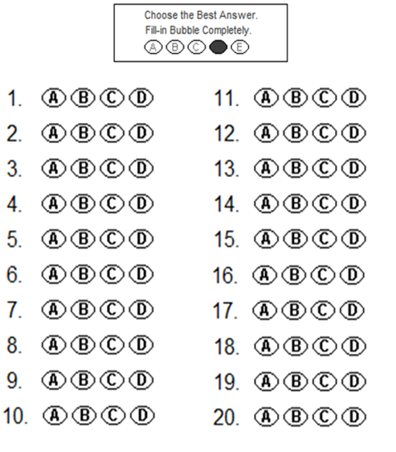



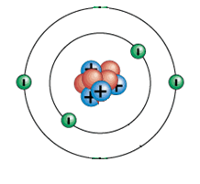**1.** The model on the right has a:

(a) Neutral charge.

(b) Positive charge.

(c) Negative charge.

(d) Nucleus charge.

**2.** The periodic table was first put together in 1869 by the chemist:

(a) Ernest Rutherford.

(b) John Newlands.

(c) Dmitri Mendeleev.

(d) Antoine Lavoisier.

**3.** Choose the correct definition for ‘atom’.

(a) The smallest part of an element that can take part in a chemical reaction.

(b) The smallest part of a cell.

(c) Anything that takes up space and has mass.

(d) The smallest part of an element that is unable to take part in a chemical reaction.

**4.** A pure substance made up of only one type of atom is called:

(a) an element.

(b) an atom.

(c) a proton.

(d) a particle.

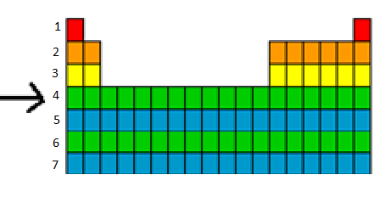**5.** The arrow is pointing to a:

(a) column.

(b) period.

(c) bar.

(d) group.

**6.** Gold is written as  on the periodic table. From this we know that:

(a) it contains 118 protons.

(b) it contains a total of 197 protons, neutrons and electrons.

(c) it contains 118 neutrons.

(d) it contains 197 electrons.

**7.** The noble gases are all:

(a) found on the right hand side of the periodic table and are highly reactive.

(b) found on the left hand side of the periodic table and are highly reactive.

(c) found on the right hand of the periodic table and are unreactive.

(d) found on the left hand of the periodic table and are unreactive.

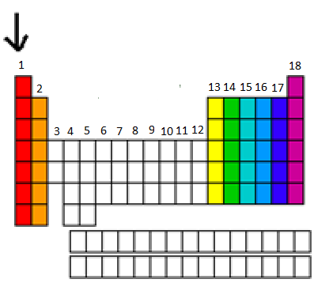**8.** The arrow is pointing to a:

(a) row.

(b) period.

(c) group.

(d) bar.

**9.** Which of the following are all transition metals?

(a) Li, Mn, Ca.

(b) Mn, Fe, Cu.

(c) F, Cl, Br.

(d) Na, K, Fe.

**10.** A particular atom has 8 protons, 8 electrons and 9 neutrons. Its atomic number is:

(a) 8.

(b) 9.

(c) 16.

(d) 17.

**SECTION B: SHORT ANSWER (40 marks)**

**1.** Fill in the table below. (10 marks)

|  |  |
| --- | --- |
| **Element Name** | **Element Symbol** |
| Helium |  |
|  | Be |
| Carbon |  |
|  | P |
|  | K |
| Calcium |  |
|  | Li |
|  | B |
| Silicon |  |
|  | S |
|  | Cl |
| Oxygen |  |
|  | H |
| Nitrogen |  |
|  | F |
| Neon |  |
| Aluminium |  |
|  | Ar |
| Sodium |  |
|  | Mg |

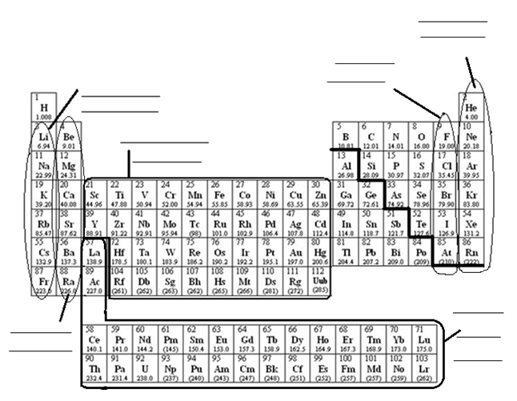**2a.** Fill in the diagram of the periodic table below. (6 marks)

**b.** Fill in the table below using the periodic table above. (2 marks)

|  |  |
| --- | --- |
| Element | Group number and/or name from the periodic table |
| Lithium |  |
| Helium |  |
| Chlorine |  |
| Iron |  |

**3.** State the number of electrons that fill the shells in an atom. (1.5 marks)

First shell: ______________

Second shell: ______________

Third shell: ______________

**4.** Label the diagram of the atom below. (2.5 marks)

 **___________________**

**_____________________**

**___________________**

**_____________________**

**___________________**

**5.** Complete the electron configurations below (neatly in pencil). (3 marks)

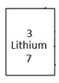

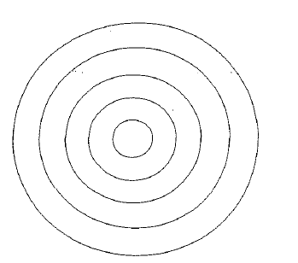

**6.** Fill in the table below using the periodic table supplied. (10 marks)

|  |  |  |  |  |  |
| --- | --- | --- | --- | --- | --- |
| Element | Atomic number | Mass number | Number of protons in each atom of the element | Number of neutrons in each atom of the element | Number of electrons in each atom of the element. |
| Silver |  |  |  |  |  |
| Helium |  |  |  |  |  |
| Magnesium |  |  |  |  |  |
| Sodium |  |  |  |  |  |

**7.** Draw a graph using the information from the table below. (5 marks)

Don’t forget all the things that a graph needs!

|  |  |
| --- | --- |
| **Year** | **Number of elements known** |
| 1700 | 13 |
| 1750 | 15 |
| 1800 | 34 |
| 1850 | 59 |
| 1900 | 84 |
| 1950 | 98 |
| 2000 | 114 |

[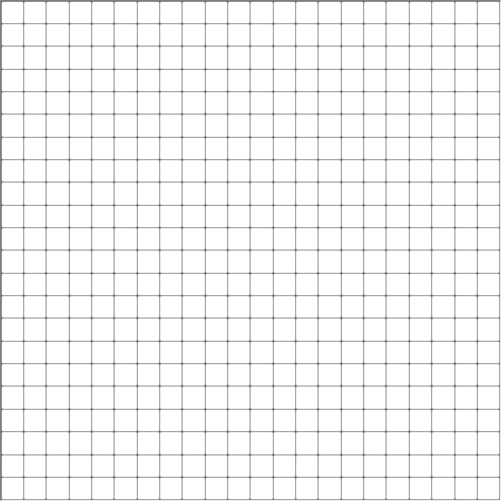](http://www.google.com.au/url?sa=i&rct=j&q=graph+paper&source=images&cd=&cad=rja&uact=8&docid=bnDyK-WDEHhooM&tbnid=OH_xw5ZTcFEuvM:&ved=0CAUQjRw&url=http://virtualmathtutor.blogspot.com/2010/11/how-to-draw-circle-without-compass.html&ei=RKw4U5fxF8fClQWCrIGoCQ&psig=AFQjCNHahbsWAgdANQM5RZCXw4z48cLLBw&ust=1396309252654415)

